Question-1:
Create a NumPy array containing the integers from 1 to 20. Perform the following operations:
1. Display the array.
2. Find the shape of the array.
3. Find the maximum and minimum values.
4. Calculate the mean and standard deviation.
5. Reshape the array into a 4 × 5 matrix.
6. Display the second row of the matrix.
7. Display the third column of the matrix.
Code:
import numpy as np
arr = np.arange(1, 21)
print("1. Display Array:\n", arr)
print("\n2. Shape of the array:", arr.shape)
print(f"\n3. Max value: {arr.max()}, Min value: {arr.min()}")
print(f"\n4. Mean: {arr.mean()}, Standard Deviation: {arr.std()}")
reshaped = arr.reshape(4, 5)
print("\n5. Reshaped Matrix (4x5):\n", reshaped)
print("\n6. Second row:", reshaped[1])
print("\n7. Third column:", reshaped[:, 2])

Output:
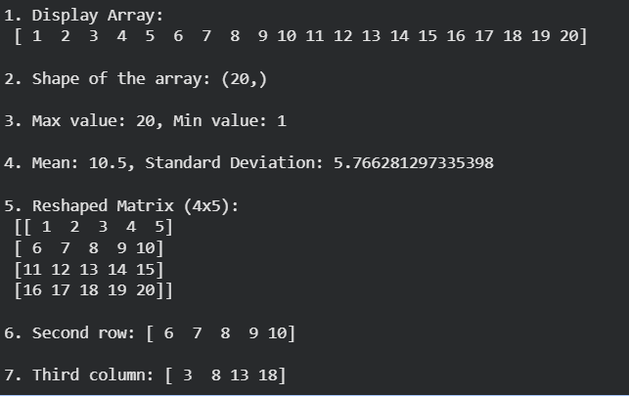

Question-2:
Create two NumPy arrays: A = [10, 20, 30, 40, 50] B = [5, 10, 15, 20, 25]
Perform: 1. Addition of A and B.
2. Subtraction of B from A.
3. Element-wise multiplication.
4. Element-wise division.
5. Find the sum of all elements in A.
Code:
import numpy as np
A = np.array([10, 20, 30, 40, 50])
B = np.array([5, 10, 15, 20, 25])
print('1. Addition:', A + B)
print('2. Subtraction:', A - B)
print('3. Multiplication:', A * B)
print('4. Division:', A / B)
print('5. Sum of all elements in A:', A.sum())
Output:
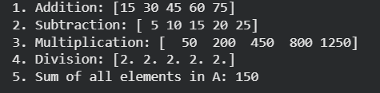

Question-3:
Create a DataFrame using the following student data: Roll No Name Marks 101 102 103 104 105 Ravi 85 Priya 92 Kiran 78 Anu 88 Sita 95 Perform the following operations: 1. Display the DataFrame. 2. Display the first three records. 3. Find the average marks. 4. Find the student with the highest marks. 5. Find the student with the lowest marks. 6. Add a new column called "Grade" using: o A for Marks ≥ 90 o B for Marks between 80 and 89 o C for Marks < 80
Code:
import pandas as pd
data = {
"Roll no": [101, 102, 103, 104, 105],
"Name": ['Ravi', 'Priya', 'kiran', 'anu', 'sita'],
"Marks": [85, 92, 78, 88, 95]
}
df = pd.DataFrame(data)
print("1. Full DataFrame:")
print(df)
print("-" * 40)
print("2. First three records:")
print(df.head(3))
print("-" * 40)
print("3. Average Marks:", df.Marks.mean())
print("-" * 40)
highest_marks_student = df[df.Marks == df.Marks.max()]
print("4. Student(s) with highest marks:")
print(highest_marks_student)
print("-" * 40)
lowest_marks_student = df[df.Marks == df.Marks.min()]
print("5. Student(s) with lowest marks:")
print(lowest_marks_student)
print("-" * 40)
def assign_grades(Marks):
if Marks >= 90:
return "Grade A"
elif 80 <= Marks <= 89:
return "Grade B"
else:
return "Grade C"
df['Grade'] = df.Marks.apply(assign_grades)
print("6. DataFrame with Grades added:")
print(df)

Output:
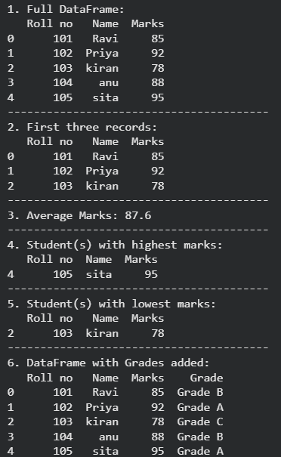

Question-4
Create a DataFrame containing the following information: Product Price Quantity Laptop 50000 10 Mouse 500 50 Keyboard 1200 30 Monitor 10000 15 Perform: 1. Calculate the total value of each product using: Total Value = Price × Quantity 2. Add the Total Value column. 3. Find the product with the highest total value. 4. Calculate the overall inventory value.
Code:
import pandas as pd
values = {
'Product': ['Laptop', 'mouse', 'leyboard', 'monitor'],
'price': [50000, 500, 1200, 10000],
'quantity': [10, 50, 30, 15]
}
df = pd.DataFrame(values)
df['Total_value'] = df.price.mul(df.quantity, fill_value=1)
print("1 & 2. DataFrame with Total_value column:")
print(df)
print("-" * 40)
highest_value_product = df[df.Total_value == df.Total_value.max()]
print("3. Product with highest total value:")
print(highest_value_product)
print("-" * 40)
overall_inventory_value = df.Total_value.sum()
print("4. Overall inventory value:", overall_inventory_value)

Output:
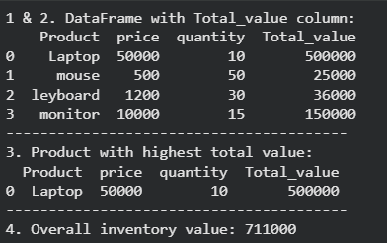

Question-5:
Download the Iris dataset from Scikit-learn and perform the following:
1. Load the dataset into a Pandas DataFrame.
2. Display the first five records.
3. Find the number of rows and columns.
4. Display column names.
5. Check for missing values.
6. Generate summary statistics using describe().
7. Find the number of samples belonging to each class.
Code:
import pandas as pd
from sklearn.datasets import load_iris
iris = load_iris()
df = pd.DataFrame(iris.data, columns=iris.feature_names)
df['target'] = iris.target
print("2. First five records:")
print(df.head())
print("-" * 40)
print("3. Shape (Rows, Columns):", df.shape)
print("-" * 40)
print("4. Column Names:", df.columns.tolist())
print("-" * 40)
print("5. Missing Values Per Column:")
print(df.isnull().sum())
print("-" * 40)
print("6. Summary Statistics:")
print(df.describe())
print("-" * 40)
print("7. Class Value Counts:")
print(df['target'].value_counts())
Output:
